- Introduction
  - This course was published by FreeCodeCamp and was created & assembled together by Scrimba, an interactive platform to learn coding and other related skills.
- Html and CSS
- HTML Tags:
  - An HTML tag is used to create an HTML element;
    - For example: <opening tag> element’s contents</closing tag>
    - Note: not all HTML elements have a closing tag, these are called “self-closing” tags, or “void elements”.
  - Each tag can have one or more “attributes”, which can help further specify how that element behaves.
  - The most important elements are the heading elements (h1 -> h6), they are used to write big/important text on the webpage, each of them varying in size respectively, h1 being the biggest size and h6 the smallest.
  - Other important elements are as follows:
    - <!DOCTYPE html>: Declares the document type to be HTML.
    - <html>: The root element that contains all other HTML elements.
    - <head>: Contains meta-information about the document, such as the title and links to stylesheets.
    - <meta>: used to provide machine-readable information (metadata) about an HTML document. (Google it for more information)
    - <title>: Sets the title of the webpage, which appears in the browser tab.
    - <body>: Contains the content of the webpage, such as text, images, and links.
    - <p>: Start a paragraph in a new line.
- The <img> tag
  - This element allows us to input an image in the html page by using the “src” attribute.
  - Example: <img src=”mars.jpg”> the file “mars.jpg” must be next to the index.html file, if not, you need to specify which folder the image is at, like “\images\space\mars.jpg”
  - Note: This is a “self-closing tag” there is no need to close it using </img>
  - By default, the loaded image will not scale with the browser’s size or in other devices, to fix that we can use the “width” attribute to specify a percentage of the screen that the image can take, ex: <img src=”image.jpg” width =”50%”>

- Nesting
  - Nesting is putting an HTML element inside another;
  - Nested elements should be indented for organisational purposes;
  - Nested elements have parent/child relation, the outer element is the parent and the inner element is the child.
  - These are used to group elements together, improving future code scalability and allowing them to be styled collectively with CSS or manipulated as a group using JavaScript.
  - Example: The <div></div> tag, it has no effect on the content of the webpage, but it is used as a container to gather HTML elements that belong together in a single group, as shown below.
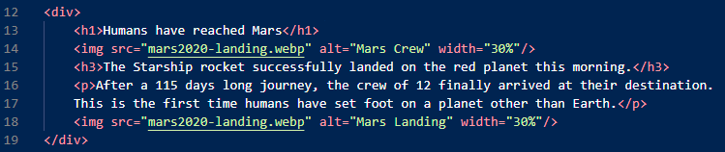
  - Visualisation of nesting: this is described as the HTML Document Tree.
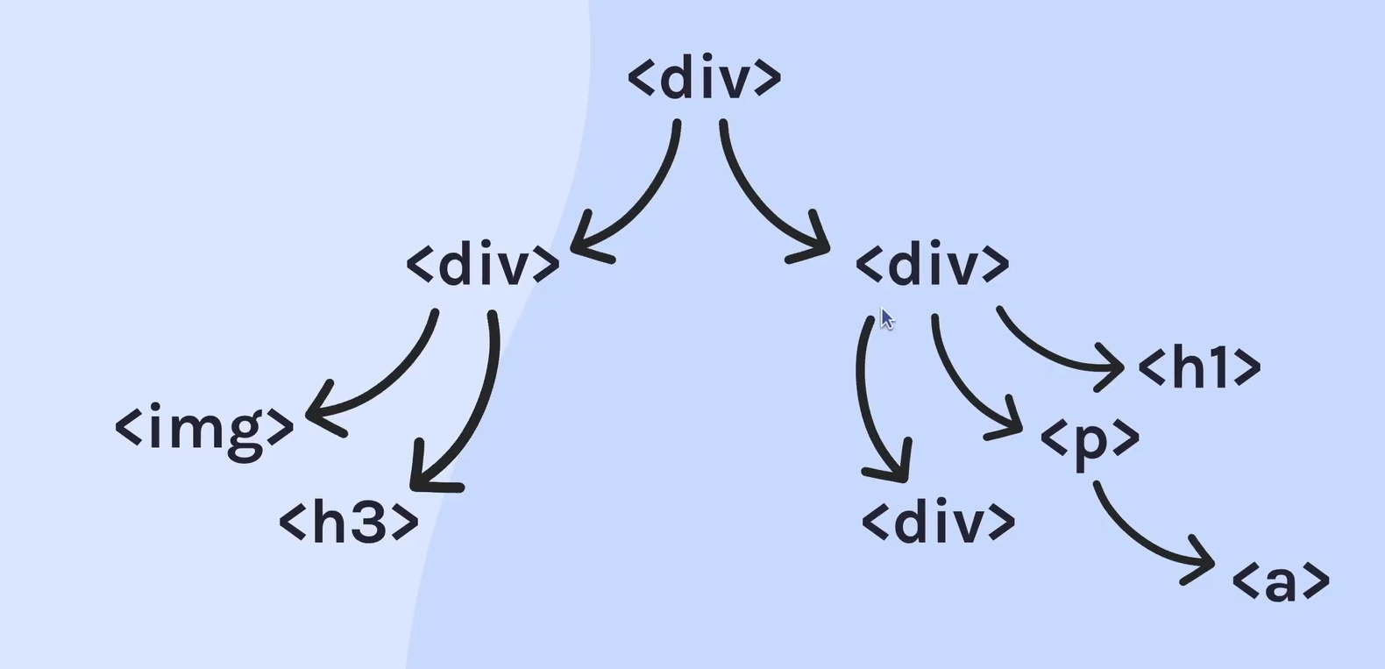
  - In HTML we can keep nesting elements within other elements as shown above, which creates a tree-like view, hence the naming of the above chart.
- Buttons
  - This tag <Button></Button> is used to create a button.
- Input tags

- Intro to CSS

- Building a business card

- Space exploration

- Birthday website

- Solo project hometown homepage

- Build a counter app

- Javascript challenges part 1

- Git and Github basics

- Build a blackjack game

- Javascript challenges part 2

- Build a Chrome extension

- Javascript challenges part 3

- Command line basics

- Essential Git and Github skills

- Advanced foundations

- Methods and loops

- Functions expressions and parameter

- Asynchronous javascript and APIs

- AI engineering fundamentals

- Build a Node API

- Build a fullstack Node app

- Introduction to databases

- Writing SQL queries

- Static pages

- Data driven

- React state

- Side effects

- Capstone project

- Typescript fundamentals

- Typescript in React

- Build a Next.js app

- Rendering strategies and more

